AP EUROPEAN HISTORY: SUMMER ASSIGNMENT 2021
Introduction:
The summer assignment is designed to introduce you to important skills necessary for academic success in the class. In addition, the assignment introduces you to the course content (major historic developments in Europe) that will be discussed at the beginning of the upcoming school year.
Purpose of Assignment:
AP European History is a fast paced, content rich class with a heavy emphasis on critical reading, writing, and thinking skills. The purpose of this assignment is to cover the content of chapter 11 of our text and to familiarize yourself to both our book and skills needed for success in class.
- Some of our early in class assessments will be based on the summer assignment.
Part I: Medici video and worksheet Due at the end of first week of classes
Directions: Follow the YouTube link and fill out the viewing guide upon watching the movie. The movie is 55 minutes.
Materials Needed:
• Part 1 of Medici: Godfathers of the Renaissance https://www.youtube.com/watch?v=GOAVRcI6mFU
• Viewing Guide 1 (PDF 84k)

Here is the link for a pdf version of the book:

https://drive.google.com/file/d/1c3TWtvwClLB-P63NzRmX5x5ApgXFjkia/view?usp=sharing

Part II Late Medieval Europe and Renaissance Italy Due second week of classes

Skill: (a) Map Comprehension

Your task: Using the Internet, textbook, or any other references, identify the following territories on the maps presented below.
MAP 1: 14th – 15th Century Map of Europe:
- The Holy Roman Empire I. The Papal States
- France J. Russia (The Russian Principalities)
- Kingdom of Castile K. Sweden
- Kingdom of Aragon L. Kingdom of Naples
- The Ottoman Empire M. Poland
- England N. Lithuania
- Scotland O. Teutonic Knights/Prussia
- Kingdom of Navarre P. Portugal

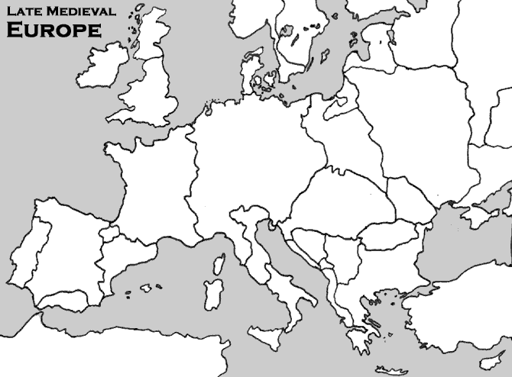

- Map 2: Italy, c.1450.
Map of Italy, c.1450 | On the map, identify:
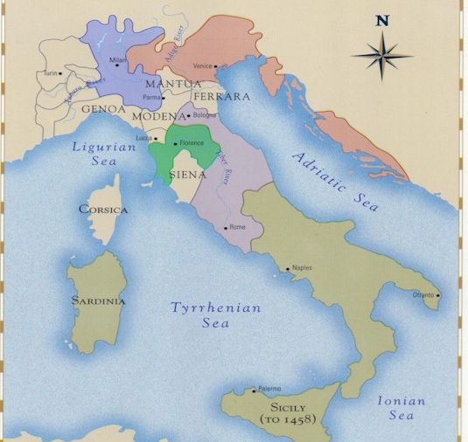 | - Dutchy of Milan  - Republic of Venice  - Papal States  - Republic of Florence  - Kingdom of Naples

Part III Vocabulary Due second week of classes

Skill: Definition/explanation of key terms - During the school year, you will be expected to define / explain a list of key terms for every chapter. Most of the key terms will be mentioned and/or described in the textbook. You will have to use outside sources for others. When addressing this part of the class, you are expected to provide a complete definition for each key term (who, what, where, when) as well as briefly explain the significance of each term.
Example:
RENAISSANCE:

Period of European history that is associated with the revival (rebirth) of interest in Greco-Roman cultures. The Renaissance first emerged and developed in the Italian city-states, such as Florence, Venice, Rome, Urbino, and Milan during 14th and 15th centuries. It represents a distinct period in European history: a break from the Middle Ages and beginning of progress for the European civilization.
Your task: Using attached pages from the pdf. textbook as well as the Internet, define the following key terms. Estimated time to complete assignment is 10-15 minutes.
The Black Death –

Pogroms –

The Statute of Laborers (1351) –

The Jacquerie –

The English Peasant Revolt (led by Wat Tyler) of 1381 –

The Hundred Years’ War (major causes) –

Joan of Arc –

The Holy Roman Empire (in the 14th-15th centuries) –

Condottieri –

Unum Sanctum –

The Great (Western) Schism –

Vernacular Literature (examples from the 14th century) –

Christine de Pizan –

Humanism (during the Renaissance) –

