Name: _________________________________________ Date: ______ Period:_________

**Section 8.3 and 8.4: Review**

**Part I: Each of these expressions can be simplified to a single expression using a trig function or number or combination thereof**

1. sin θ sec θ 2.  3.

4.  5. 6. 

7. 8.  9. 

**Part II: Verify the identity. SHOW ALL WORK**

10.  = cot x 11. 

12. tan θ + cot θ = (sec θ)(csc θ) 13. (sin x + cos x)2 = 1 + 2 sin x cos x

14. 15.

16. 17. cos t + tan t sin t = sec t

**Part III: Solve each equation for the interval .**

18.  19. 

20.  22.

23. 24. 

**Part IV: Graph each function.**

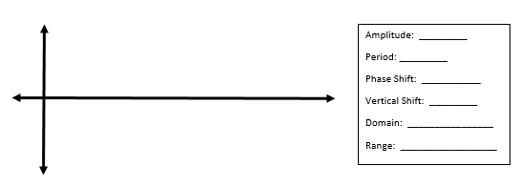25. 

Amplitude: ___________

Period: ______________

Phase Shift: __________

Vertical Shift:_________

Domain:_____________

Range: _____________

26. 

Vertical Stretch/Shrink:______

Period: __________________

Phase Shift: ______________

Vertical Shift:_____________

Range: __________________