Name: _________________________________________ Date: ______ Period:_________

**Transformations of Functions Practice**

**Part 1 Directions**: Provide the name of the parent function and describe the transformation represented. You may use your graphing calculator to compare & sketch.

1) 

Parent: ______________________________________

Transformations:________________________________

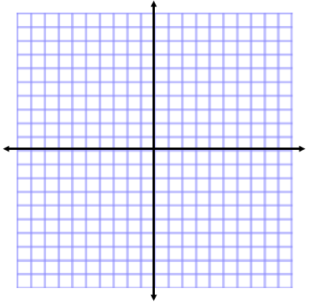  
**2)** 

Parent: ______________________________________

Transformations:________________________________



3) 

Parent: ______________________________________

Transformations:________________________________

  
4)  

Parent: ______________________________________

Transformations:________________________________



**Part 2 Directions:** Given the parent function and a description of the transformation, write the equation of the transformed function, f(x).

a) Absolute value with vertical shift up 5, horizontal shift right 3

b) Linear with vertical stretch/compression by a factor of 

c) Square Root with vertical stretch by a factor of 8 and a horizontal shift down 3

d) Quadratic with horizontal shrink by a factor of 5, horizontal shift left 8

**Part 3 Directions:** Sketch each transformation on the same graph as the original.

1. 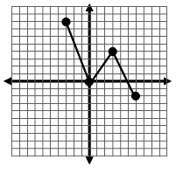Draw  b) Draw  c) Draw 

**e)** Draw  f) Draw  g) Draw 