Economics and Personal Finance

Washington-Liberty High School
1301 N. Stafford St, Arlington, VA 22201
703-228-6200

Dear Students,

Welcome to Economics & Personal Finance! This year, we will learn about how money and the US economic system affect our lives. We will learn about banking, credit, budgeting, and how to prepare for our best financial future. We will also work to improve our English, so we can read, speak, and write about the world around us.

- Mrs. Robbins

Email: Emily.Robbins2@apsva.us

Class Objectives

Our course follows the Virginia competencies for Economics & Personal Finance.

We also incorporate the state WIDA English language proficiency standards.

In this class, you will improve your reading, writing, listening, and speaking in English. This will help you prepare to study Social Studies in the future.

Materials
You will need these things every day in class:
- A pencil
- Your EPF Binder
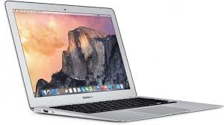
- Your CHARGED Macbook Air
- A good attitude!

Textbooks & Materials
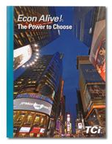
Our textbook is EconAlive! published by Teacher’s Curriculum Institute. You can access this text online through Canvas and at school.

In addition to textbooks, we will use our computers to read online information about Economics and Personal Finance. We will use these websites:
- Canvas online learning platform: http://instructure.apsva.us
- Google Drive: http://drive.google.com
- Quizlet: http://quizlet.com
- Everfi Financial Literacy Program: https://platform.everfi.net

Students will access these sites using their APS login information.

Financial Literacy Certification
All EPF students will be taking the W!SE Financial Literacy Exam during the school year.
Students are expected to pass the exam and receive the certificate based on being active participants with the material covered in class.
This is a great certificate to list on college and employment applications and shows that you have mastered the topics over the course of the year.

Grading
Your grade will show how well you meet the objectives for each assignment.

Students are expected to act honorably in class (and in school) at all times. There is a complete description of Washington-Liberty’s Honor Code and policies available in the Student Handbook and through the counseling department.

This means that students do not give or receive unauthorized help on any assignment. The penalty for cheating will be a zero on the assignment. The penalty for plagiarism (a specific form of cheating) will be a zero on the assignment.

You will be graded on many different kinds of assignments, including class work, quizzes, group projects, computer assignments, your social studies notebook, and unit exams. These assignments will count toward your final grade.

Grade Calculation
Class Work and Binders | 40%
Lesson Quizzes | 20%
Warm-Ups | 20%
Unit Exams & Projects | 20%

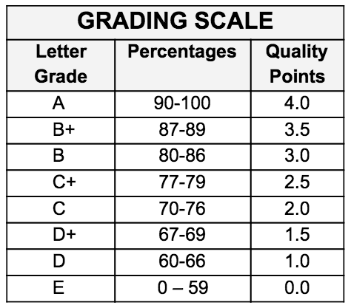

Remember
- Student grades reflect student achievement and not student behavior.
- Quarterly grades will round up when the percentage is .5 or higher.

Final Exam
Students who have an A average for the year will be exempt from taking the final exam in Economics. All other students will be required to take the exam, no exceptions.
For students taking the final exam, final grade will be calculated as follows:
First Quarter - 20%  Second Quarter - 20%  Third Quarter - 20% | Fourth Quarter - 20%  Final Exam - 20%

Planned Course Sequence
Here are some of the things we might study this year:

Topics and Essential Questions | Timeline | Virginia  SOL | When/How Assessed
Unit 1: Banking and Savings | September | EPF .6  EPF .12 | Lesson Quizzes  Unit Exams  Group Projects
Unit 2: Credit and Consumer Protection | October - November | EPF .10  EPF .13
Unit 3: Money Management | November - December | EPF .11  EPF .16  EPF .17
Unit 4: Insurance | December - January | EPF .14
Unit 5: Investing | January | EPF .18
Unit 6: Economics | February - March | EPF .1 - EPF .9
Unit 7: Planning for your Future | May-June | EPF .10  EPF .17

English Language Development

As a EL class, our top priority is to improve our English language. This year, we will . .

- Build academic vocabulary in Social Studies, Finance, and Economics

- Increase reading skills by reading nonfiction documents, as well as how to read and understand financial documents such as bank statements, pay stubs, credit card applications, and tax returns

- Improve writing by practicing persuasive, informative, and compare/contrast essays, as well as learning how to write a resume, a cover letter, and a college application essay

- Focus on speaking and listening in real-world situations such as visiting a bank, choosing an insurance plan, or a job interview

Expectations

In Economics and Personal Finance, your teachers
expect you to:

- Be respectful - of peers, teachers and yourself
- Do your work
- Be present in class - participate in class discussions, share your opinion and ideas respectfully
- Be proactive - TALK TO ME if you’re having a problem!

Cell Phone Policy

Cell phones or headphones are not to be out during class time unless otherwise instructed.

Attendance & Late Work Policy

You must be present in class to complete work. Chronic absences and tardies will be subject to the school’s attendance and disciplinary policy, found in the Student Handbook.

If you miss a day, please check Canvas under the “Miss Class?” page linked on the home page for any missed assignments or contact Mrs. Robbins through email or Canvas.

Mrs. Robbins (room 3008) are available during GP (with a pass) to complete unfinished work!

